Homework Set 1

1. Two schoolchildren race across a playground for a ball. Tim starts running at a distance of 15 m from the ball, Jan starts running at a distance of 12 m from the ball. If Tim’s average speed is 4.5 m/s and Jan’s average speed is 4.0 m/s, which child will reach the ball first? Show how you arrived at the answer.

2. The two short sides of a right triangle ABC (shown below) is A = 3 cm and B = 4 cm long, respectively. What is the length of the hypotenuse C? What is the value in degrees for angle α?
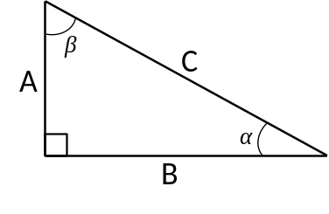
3. Within the triangle shown below, the length of B = 17 cm, C = 11 cm, and α = 53 degrees. What is the length of side A? What are the values in degrees for angles β and γ? (Law of Cosines)
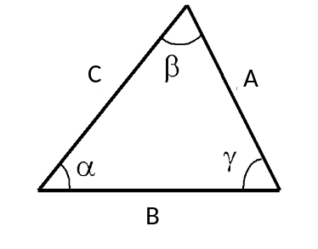

4. What is the length of the femur shown below? What is the value of angle θ in degrees?
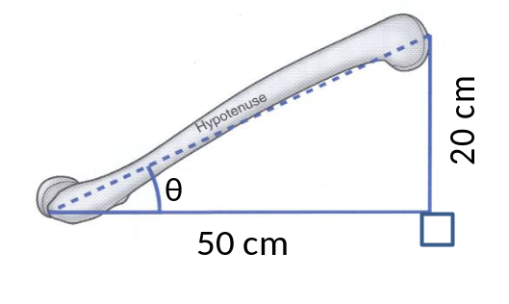
5. Define Biomechanics.

6. Mark the activities in which the biomechanists might be interested by placing “Yes” in the last column.
Num | Activities | Yes or No
1 | Improving a softball player’s swing
2 | Employees’ sign-in record
3 | The stiffness and stress of the cellular membrane of plants
4 | The flight of hawks
5 | Modifying a hammer-thrower’s throw technique
6 | A turkey’s gait on treadmill
7 | Changing a quarterback’s throw
8 | Altering the starting order of a basketball team
9 | How to increase the friction force to prevent older adults from falling
10 | Design a bridge which can sustain 100-ton force

